**Azure Site Recovery LAB**

Scenario: Assume that I am in one of the organizations responsible for the infrastructure of Azure. I give the administrator permission (Microsoft Entra ID) to one of the employees responsible for (the database) to access various resources on Azure.

The latter created a virtual machine for me to work on (to manage the MySQl server database connection), then he wrote incorrect SQL queries and executed them, leading to unexpected changes or damaging the integrity of the data on the virtual machine, or I upgraded something on the virtual machine, which led to damage. Pre-existing files and folders.

In this case, you may need to completely restore the default device and restore it to its location before the problem.

To fix such errors i use Azure Site Recovery, you can replicate virtual machines (VMs) from your primary data center or on-premises environment to Azure. Replication can be configured for both Hyper-V and VMware virtual machines, allowing flexibility in the source environment.

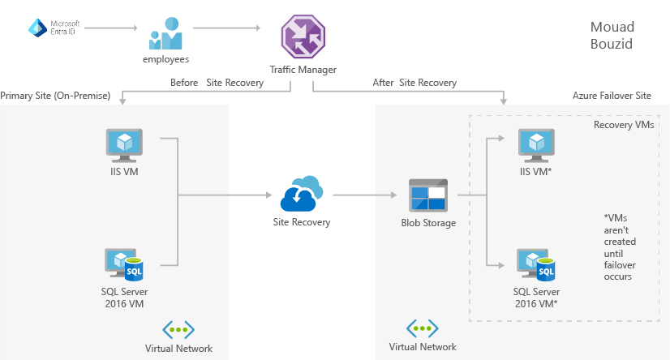

**Create a work environment**



**Create users to work on database Microsoft Entra ID**

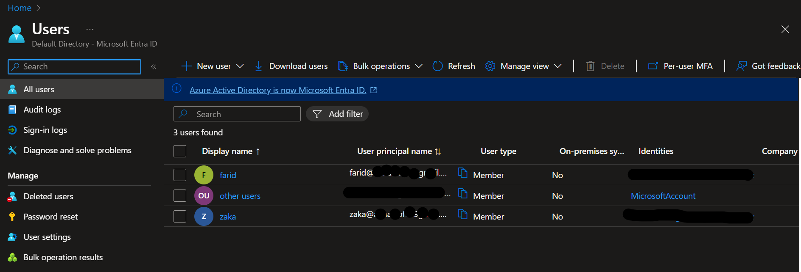

**We assume that the data administrator created the file to be worked on**

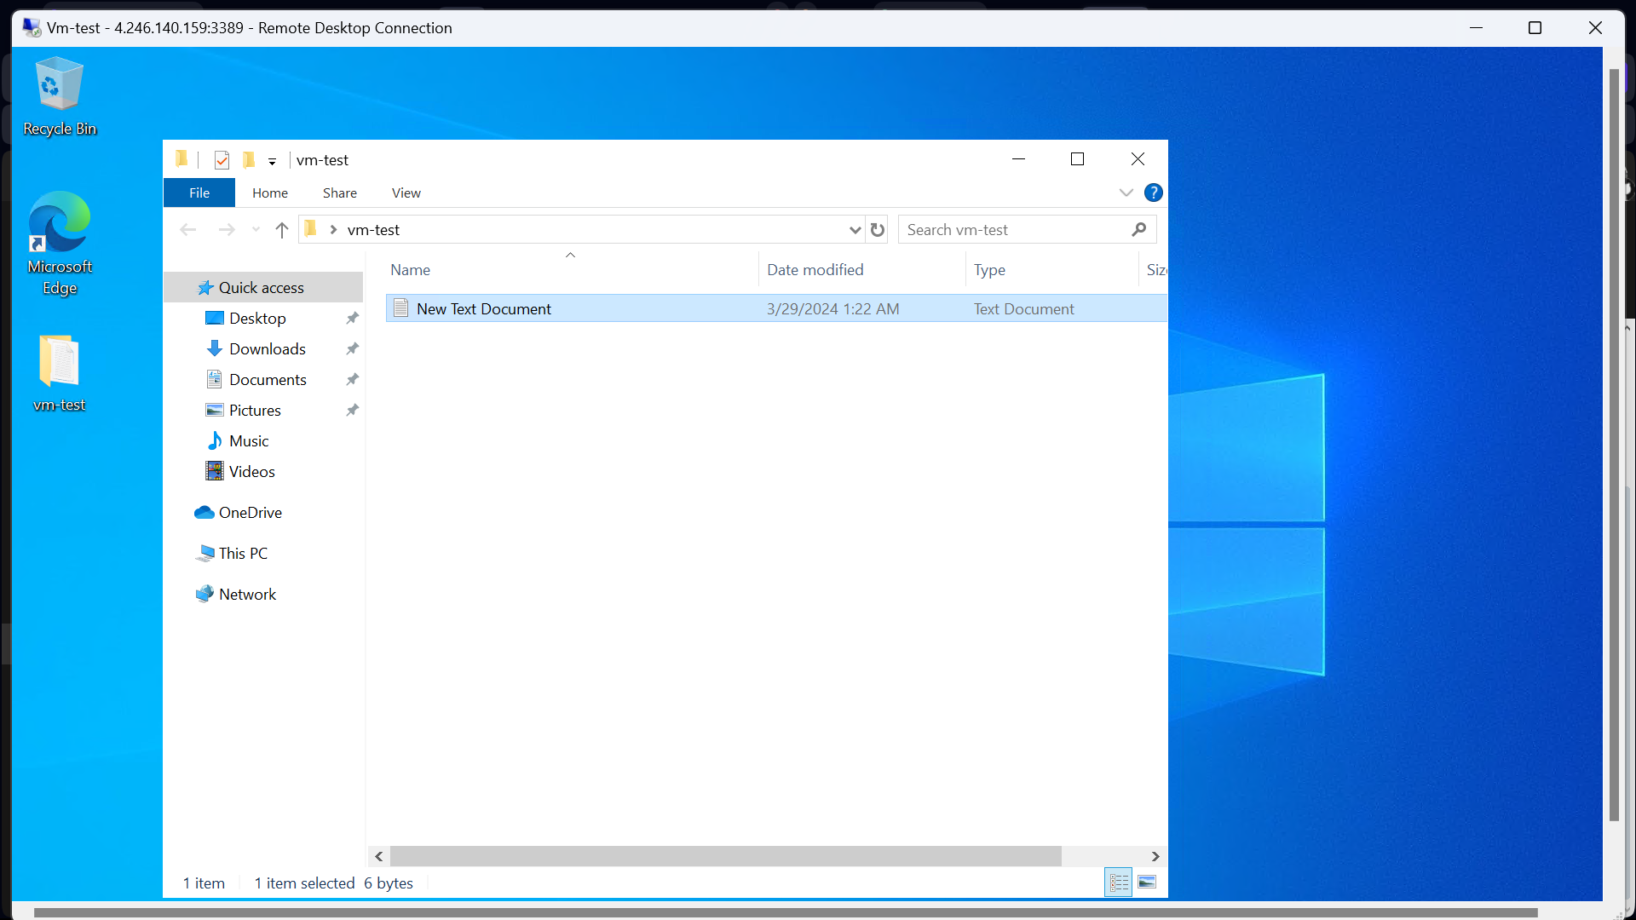

**We go to the VM to backup my VM**

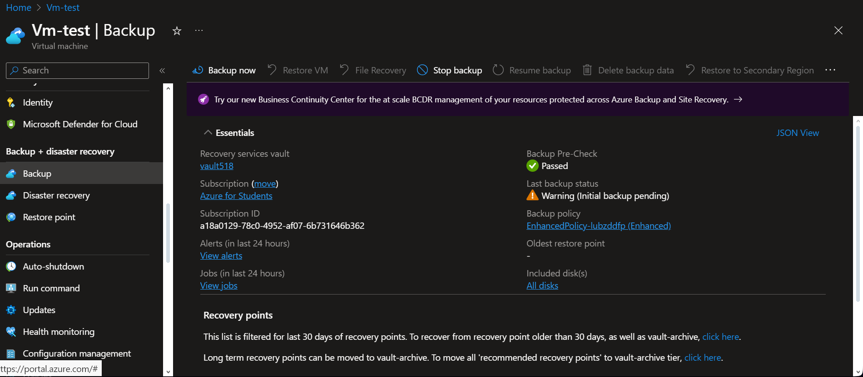

**date of backup**

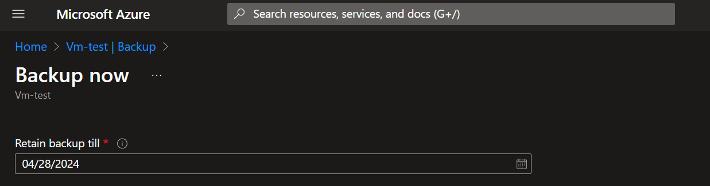

**We go to backup policies select advanced copy options**

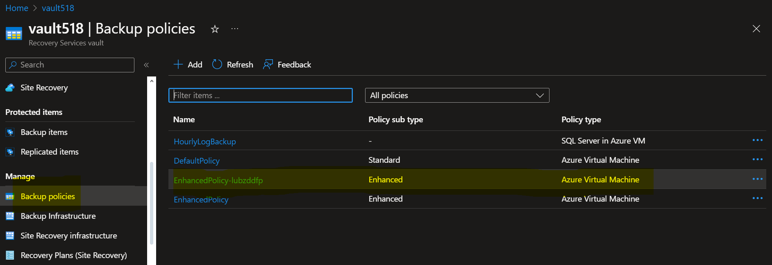

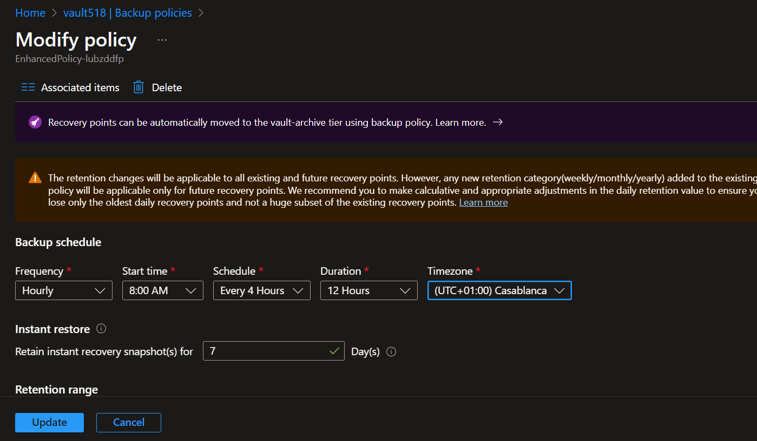

**We go to the backup functions. Note the backup time. This requires some time to complete the backup**

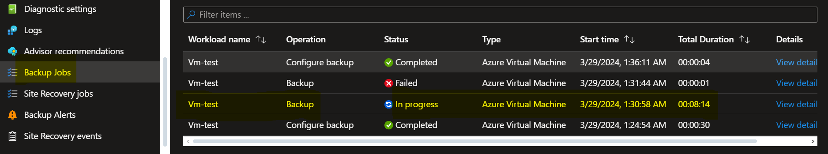

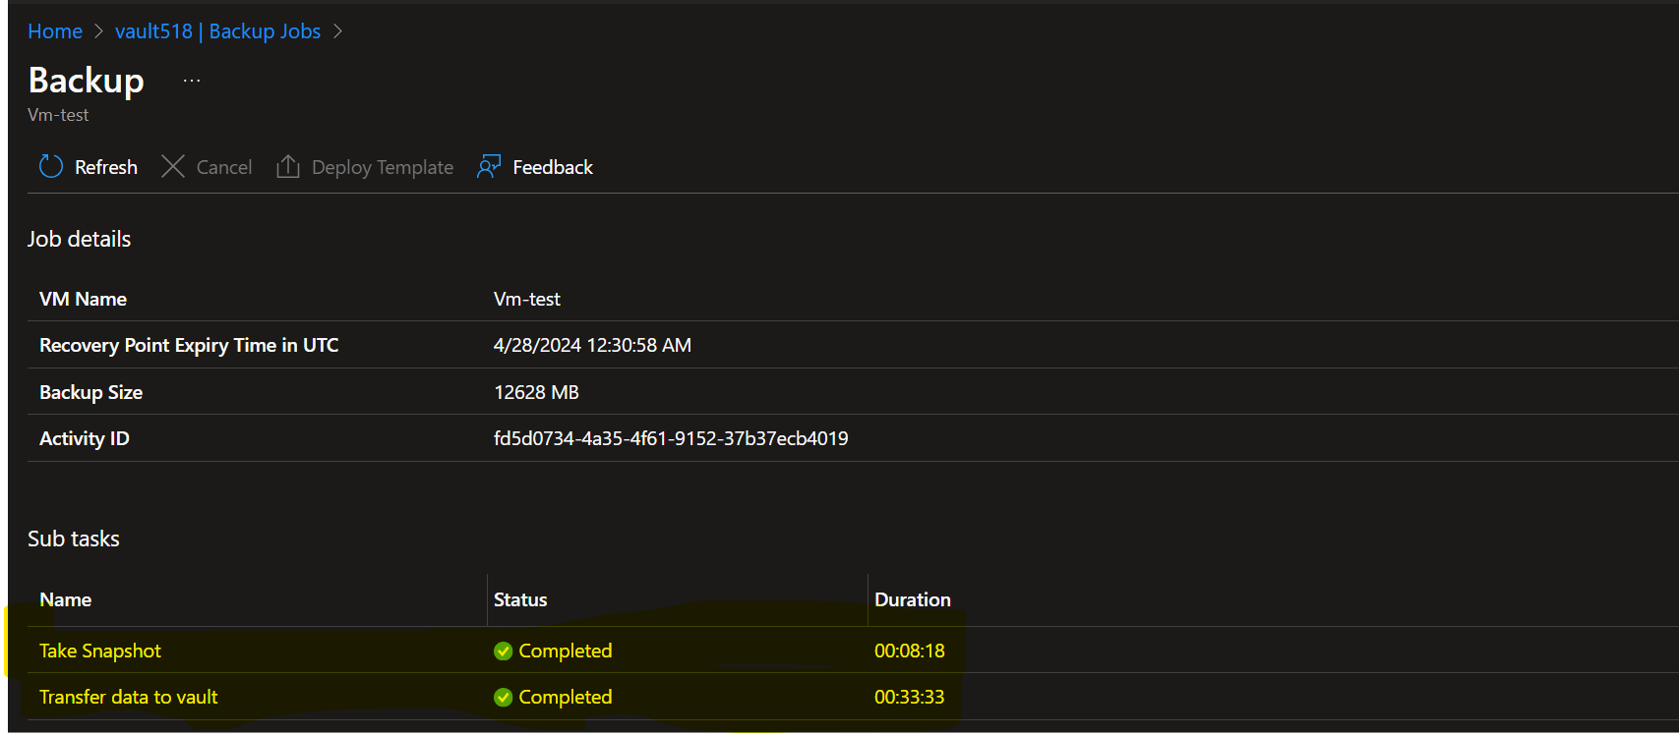

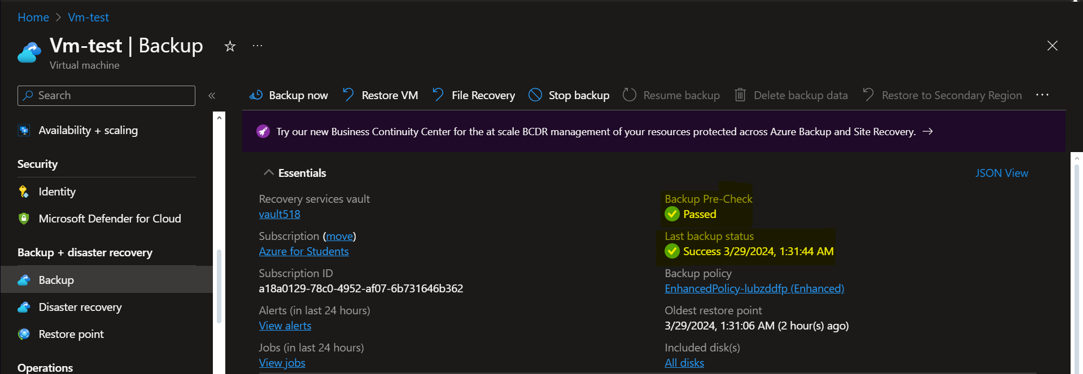

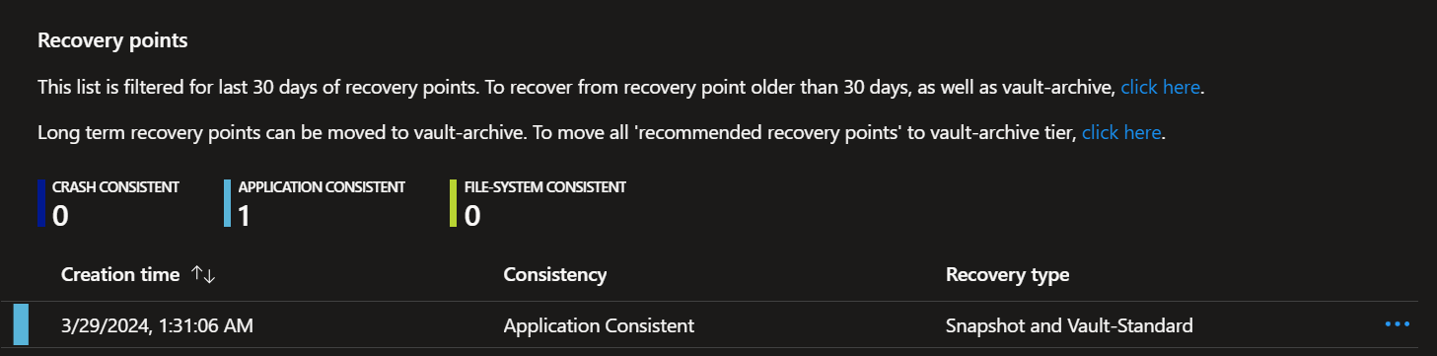

**Here we create other files that represent the changes made by the employee responsible for the data, which led to damage to the database.**

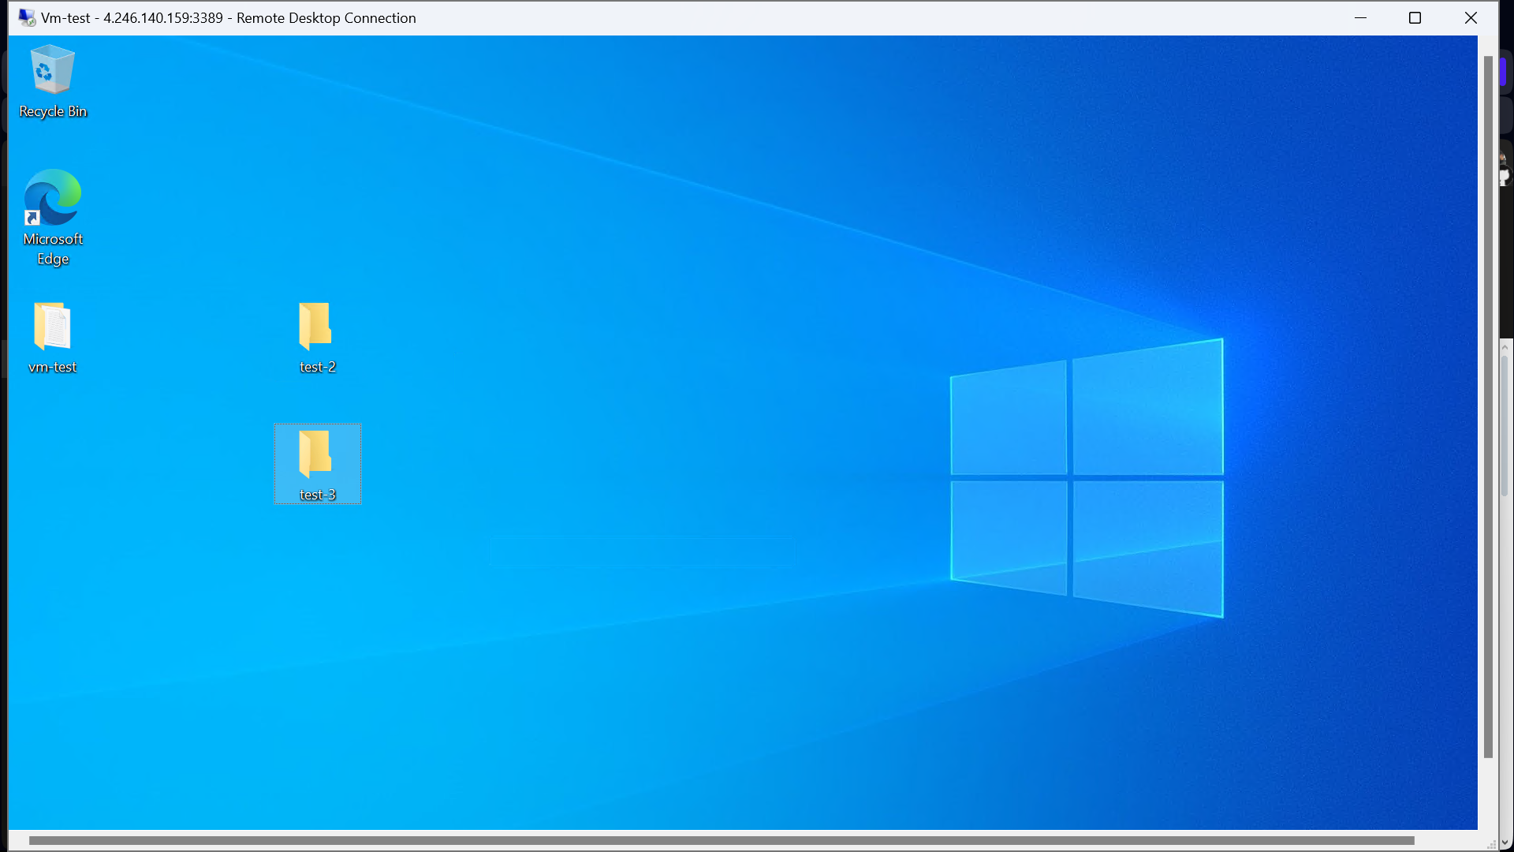

**Create a sorage account to VM**

**Staging location is the temporary location used during the in-place restore. The list populates as the staging location is the storage account in the same subscription as the vault.**

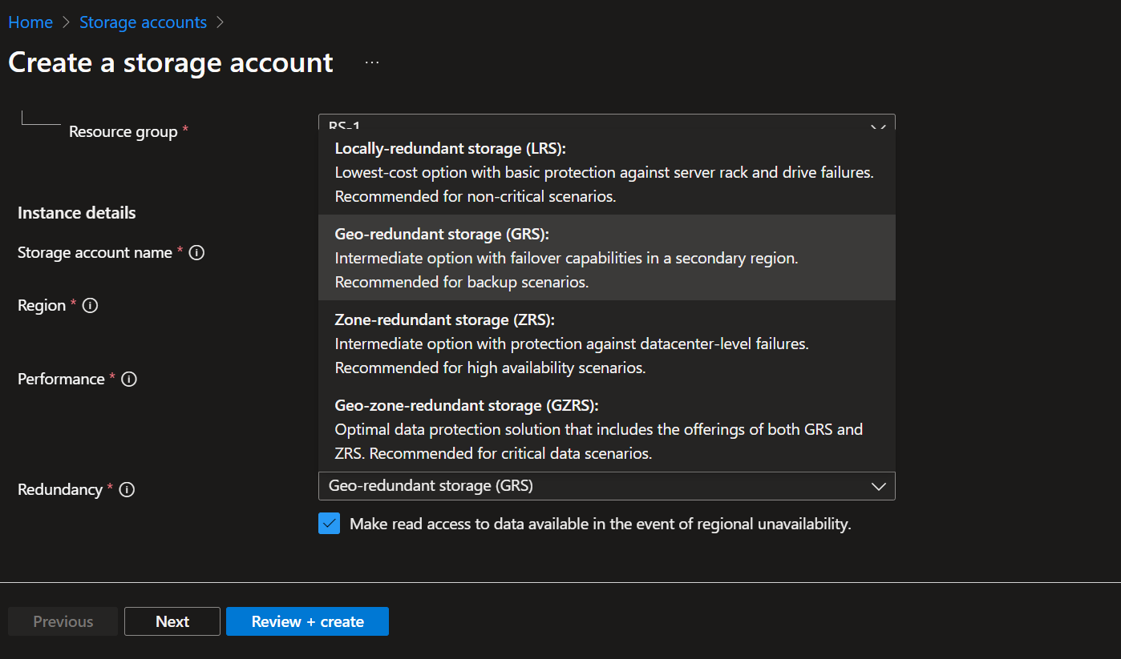

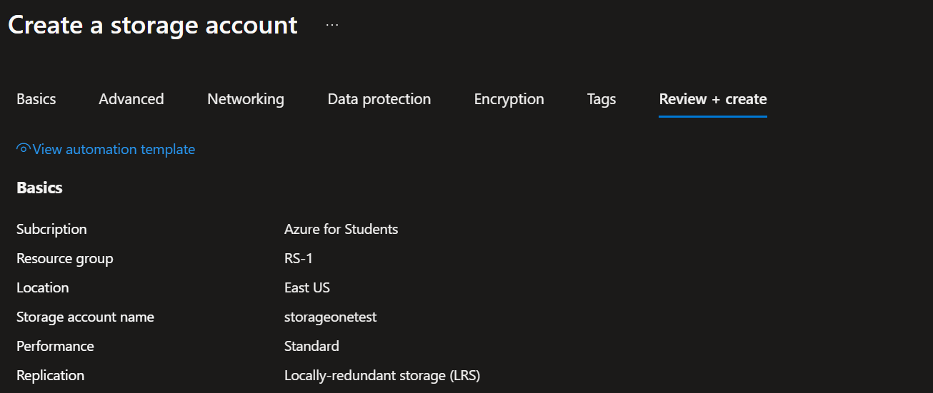

**We restore the VM to return the VM to where it was before the problem occurred**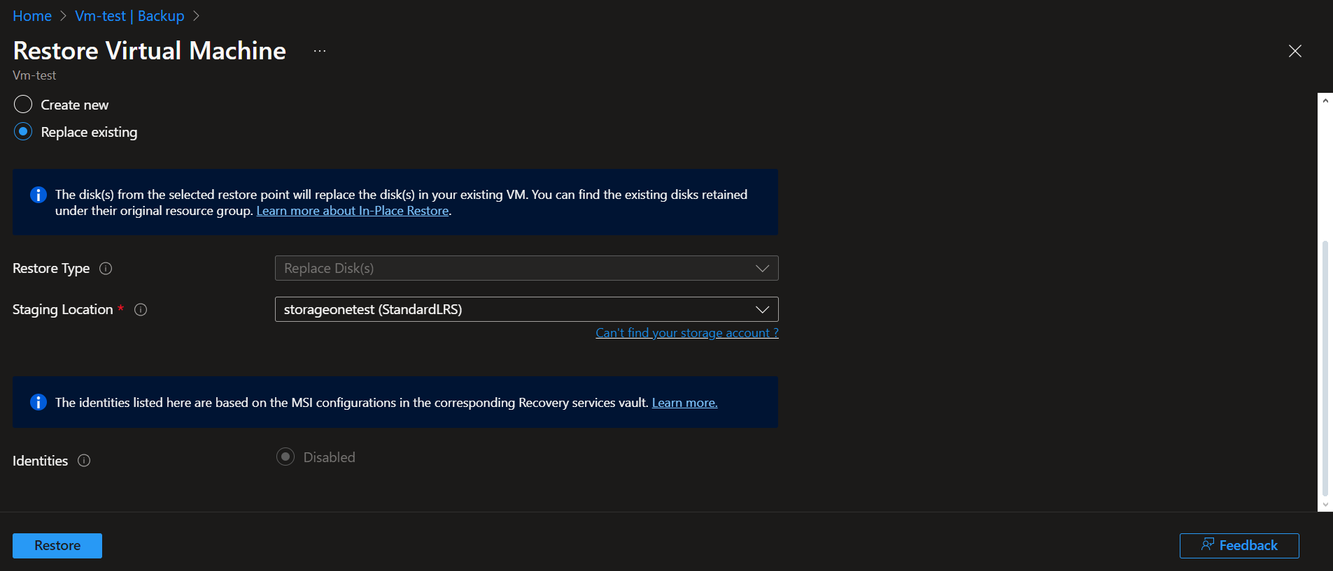

 

**This takes some time**

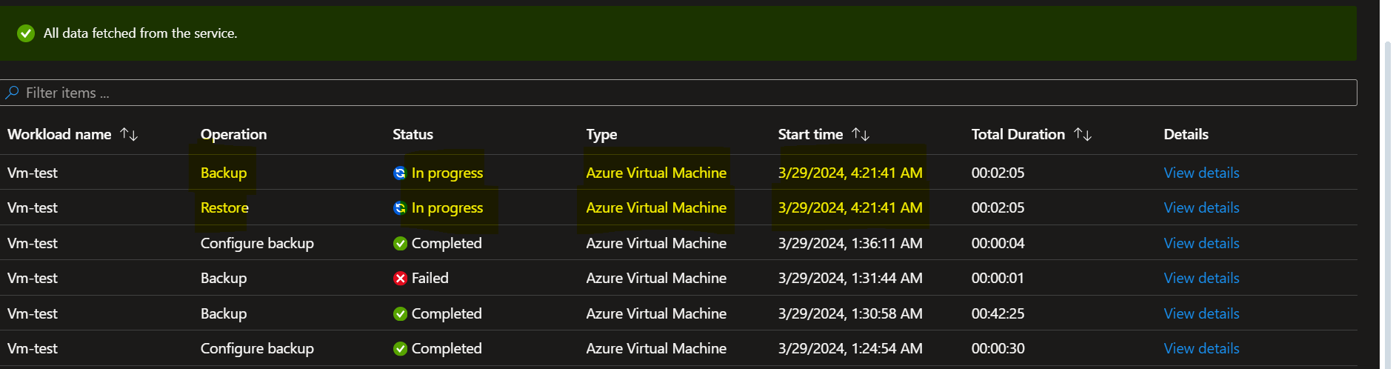

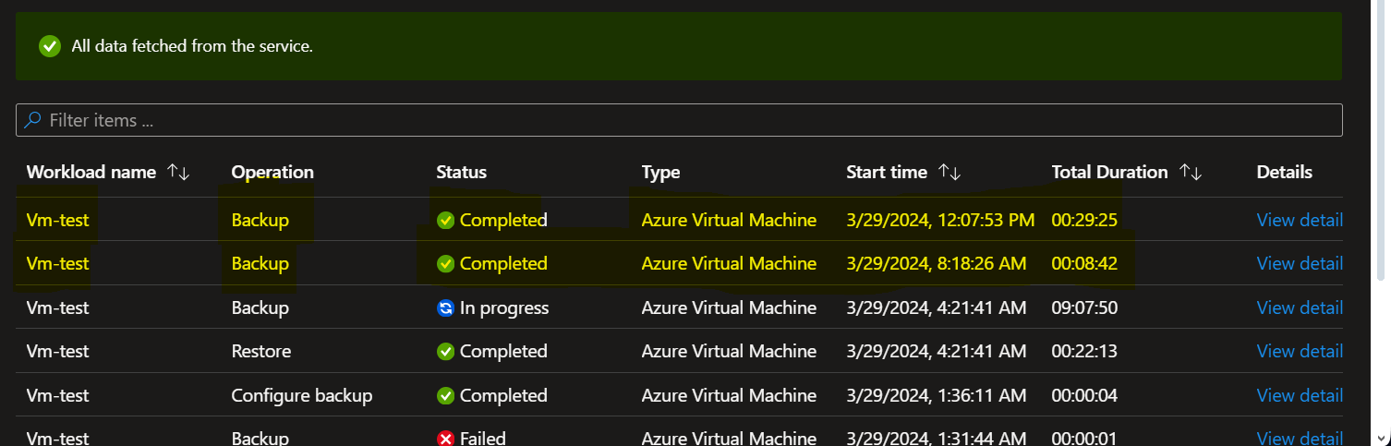

**backup is complete**

**We restart the virtual machine**

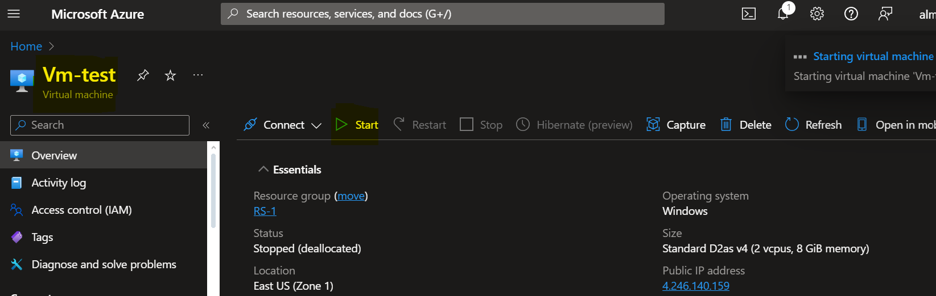

**The problem has been solved successfully. We notice that the other files responsible for the problem have disappeared**

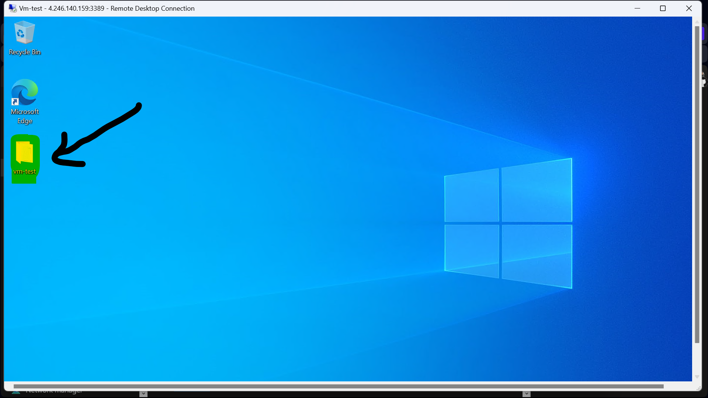

**1 - before site recovery**



**2 - During the occurrence of the problem**



**3 - after site recovery**

